# The demographics of our game

### Potential target demographic:

Male and female gamers between the ages of 15 years and 34 years who play games on their smartphones/ tablets.

### Why this demographic/ audience:

The reason i have chosen this demographic is becacuse between the age range of 16-24 and 25 to 34, there is a 44% of total age distribution of mobile games, meaning we would ahve the largest target audience possible, while still having a reasonable age range for our theme of “submarines”. What this allows is for us to get as many players into our player base which will overall help our player retention and increase the longevity of our game in the long run. As mobile gaming is just as popular among females as it is males, we feel that targeting a specific gender would only be bottlnecking the amount of people who play our game.

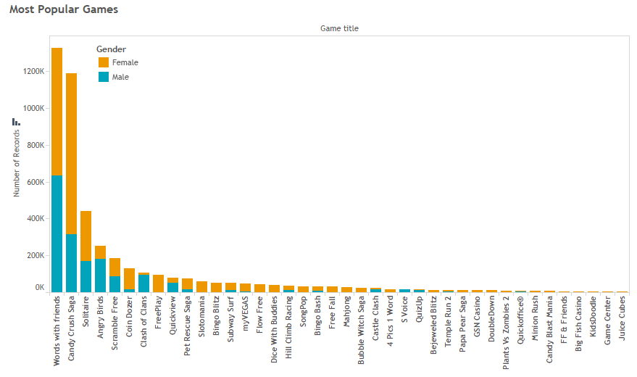

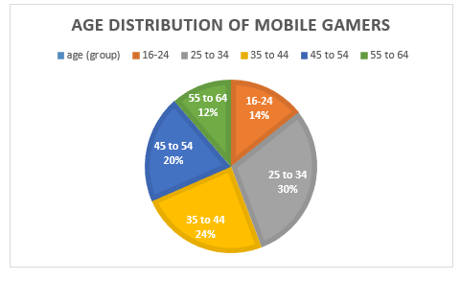

**References towards the demographics our game**

* RealityMine. (2017). *MYTH BUSTING: MOBILE GAMING DEMOGRAPHICS.* Available: http://www.mmaglobal.com/research/myth-busting-mobile-gaming-demographics. Last accessed 18th feb 2018.
* Mediakix Team. (2017). *THE 9 MOBILE GAMING STATISTICS THAT SHOW THE DOMINANCE OF GAMING APPS.* Available: http://mediakix.com/2017/05/mobile-gaming-statistics-gaming-apps/#gs.YC0DRiA. Last accessed 18th feb 2018.
* RealityMine. (2015). *Myth Busting: Mobile Gaming Demographics from RealityMine*. [online] Available at: https://www.realitymine.com/myth-busting-mobile-gaming-demographics/. Last accessed 18th feb 2018.
* Big Fish Games. (2017). *Most Popular Mobile Game Genres | Big Fish Blog*. [online] Available at: http://www.bigfishgames.com/blog/stats/most-popular-mobile-game-genres/. Last accessed 18th feb 2018.
* Big Fish Games. (2017). *The Average Gamer: Then and Now | Big Fish Blog*. [online] Available at: https://www.bigfishgames.com/blog/stats/the-average-gamer-then-and-now/ . Last accessed 18th feb 2018.
* Hwong, C. (2016). *Chart of the Week: Mobile Gamer Demographics - Verto Analytics*. [online] Verto Analytics. Available at: http://www.vertoanalytics.com/chart-week-mobile-gamer-demographics/. Last accessed 18th feb 2018.
* Bevans, A. (2017). *Who plays mobile games?.* Available: https://medium.com/googleplaydev/who-plays-mobile-games-8b33f76bb6d8. Last accessed 18th feb 2018.